**CENWP-OD-B 05 July 2022**

**MEMORANDUM FOR THE RECORD**

**SUBJECT: 22BON029 MFR AFF Lamprey Morts**

On 05 July, Columbia River Inter-Tribal Fish Commission (CRITFC) Biologists notified Bonneville Project Biologists of two lamprey mortalities found on the valve 15 trash rack in the Adult Fish Facility (AFF). The fish were scanned for PIT tags, inspected, and returned to the river.

1. Species – Pacific Lamprey (*Entosphenus tridentatus)*
2. Origin – Unknown
3. Length – Approximately 70 cm (top fish in photo) and 65 cm (bottom fish in photo)
4. Marks and tags – None
5. Marks and Injuries found on carcass – NA
6. Cause and Time of Death – Unknown.
7. Future and Preventative Measures – None

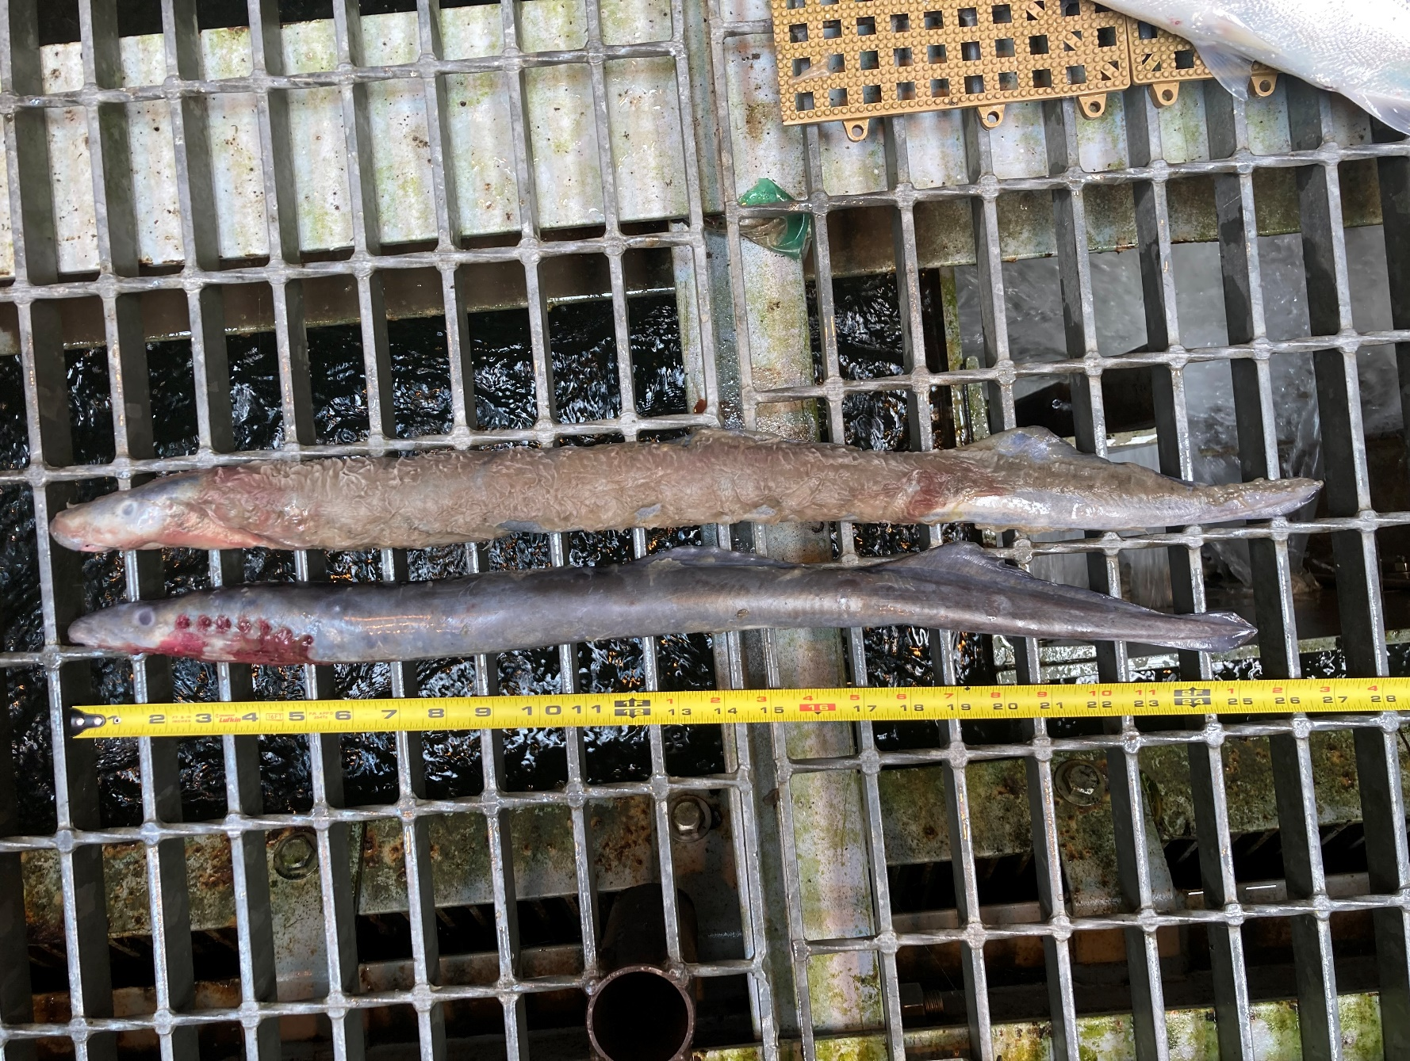Sincerely,

Bonneville Project Fisheries